COLUMBIA FIRE ZONE 2021
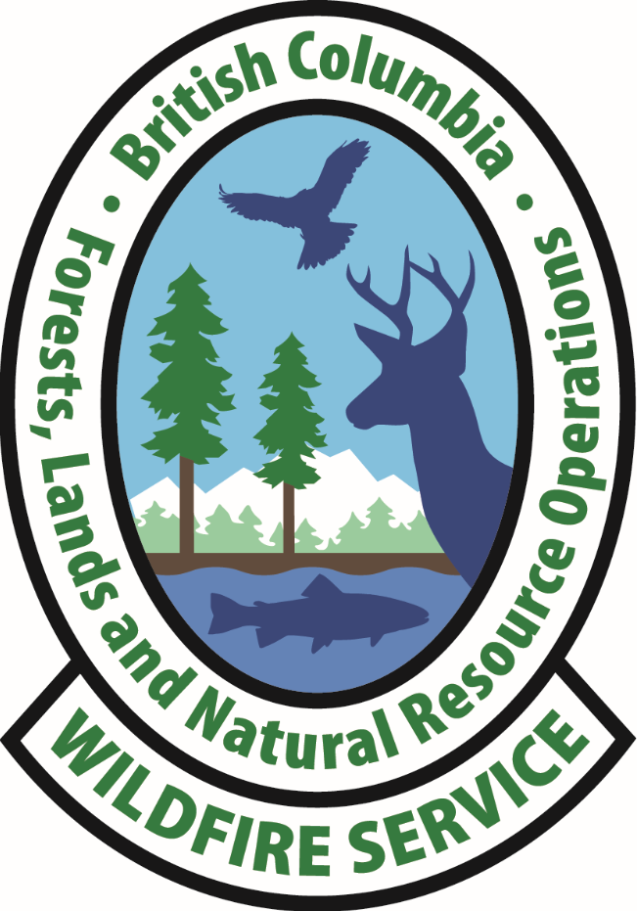

Welcome
Welcome to the Columbia Fire Zone, part of the Southeast Fire Centre. Make sure to always check in and out with the Southeast Fire Centre (SEFC). Call sign: Southeast Fire Centre.

This package includes a map of Golden and Revelstoke with the important locations highlighted, emergency procedures, repeater map, zone phone list and other useful information.

Columbia Fire Zone organization:

Wildfire Officer Quintin Balfour SE40
Wildfire Technician Stefan Hood SE41
Wildfire Technician Chad Smith SE42
Wildfire Technician Eric Hansen SE43
Wildfire Assistant Amy Collins SE44
Wildfire Assistant Ryan Clements SE45
Wildfire Assistant Alec Milne SE46
Successional Crew Leader Casey Robinson SE48
Columbia Unit Crew Supervisor Tristan Hansen Columbia 1
Monashee Unit Crew Supervisor Ian Macdonald Monashee 1
Operations Assistant Ashley Borlase SE 49
Zone Warehouse Person Ian Ward SE 89D
Southeast Fire Centre Dispatch 250 365 4001

Facilities
Revelstoke Office: 2783 Airport Way, Revelstoke
Main office for WO, 3X WT, 3X WA, OA, IA base, 1 AMA, 5 IA crews: SE410, SE420, SE430, SE450 and 2 Unit Crews (Columbia and Monashee)
Golden Forward Attack Base: 206 Fisher Rd, Golden (Located at Airport.) No personnel staffed regularly.

- The Revelstoke Office hours of operation are Monday to Friday 08:00 – 16:00 hours, with lunch from 12:00 – 13:00 hours. Unit Crew work hours are from 8:30 – 16:30, with lunch from 12:00 – 13:00. IA crew work hours are 08:30 – 16:30, with lunch from 12:00 – 13:00. These can change due to project work and or direction from the Zone Wildfire Control Officer (ZWCO).
- There is no standby at lunch break unless authorized by the ZWCO.
- Dispatch while on Standby is 30 minutes from dispatch to skids off (or wheels roll), unless otherwise notified. Dispatch while working is immediate.
- Crews must be prepared for immediate dispatch with personal gear for up to 2 weeks.
- As you know, with firefighting, lunchtime is subject to change; make sure you get your lunch break. It is expected that crew leaders and incident commanders will follow OSWS2.
- Notify ZWCO of hours and days of rest when you arrive at the zone. An eight-hour break between shifts is mandatory, unless otherwise approved by Southeast Fire Centre Operations Chief (SE OPS) or the Regional Wildfire Coordination Officer (RWCO).
- If deemed necessary, you will be issued a key and alarm code for our zone buildings. Should you enter the buildings without deactivating the alarm, sirens will go off and the RCMP will be immediately dispatched. Don’t forget the code!

Warehouse
You will need to get permission from the Asset management Assistant (AMA) or ZWCO before removing anything from the warehouse.
- A FS17 will be filled out when signing out or returning equipment.
- FS17’s go to the Ops Building; keep a copy and follow up when you return item, otherwise:
- A Field FS17 will be required when you are leaving equipment in another zone or receiving equipment from another zone
The appropriate zone staff member will enter this information into IMIS. If you require special equipment or we do not have certain items that you need to do your job, please ask the AMA or the ZWCO and we will do our best to get it for you.

Lock Up Procedure
In the event that any out of zone are the last to leave the base, the following procedures should be followed:
- All equipment to be put away and general clean around the base, please recycle bottles and keep lids on garbage containers
- All electrical appliances are turned off (coffee pots, electrical tools)
- All windows need to be locked
- All doors and gates need to be locked (fuel sheds, warehouses, locker rooms, sea cans and sheds)
- Lights turned off, blinds closed
- Offices alarmed and locked

Zone Information
The Columbia Fire Zone is large, at 1.8 million Ha. It extends from the Alberta border to the East though to the Clan William Bridge (near Three Valley Gap) to the west and just north of Mica Dam to the north and Pingston Creek to the south. Mount Revelstoke and Glacier National Parks are completely within our zone and we share boundaries with Yoho and Kootenay National Parks. Highway 1 connects the zone East-West. In the west, Highway 23 is the main artery North-South. In the east, Highway 95 and the Bush River FSR link North-South. See attached map.

Printers
To print a document, you can use the following printers:

- HP Laser Jet 700 Colour MFP @ \\FIRELINE\P11176 - Operations Building
- HP Laser Jet 500 MFP @ \\FIRELINE\P11457- Officer Building
- HP Laser Jet 600 M602 @ \\FIRELINE\P11010 - UC Hanger
- Golden Printer IP Address: 142.26.193.132

Radio Info
The Columbia Zone utilizes Tone 3. Around Revelstoke, the ‘Green’ repeater is best and around Golden, the ‘Black’ works best. As you move away from the towns the channels change to other colors (consult repeater map for details.) Radio and cellular coverage is good throughout Golden and Revelstoke. Cellular coverage is good on Highway 1 but limited in every other direction.

Contact Information
Revelstoke Office ZWCO 250-805-6732
Golden FAB Fax 250-344-7598
ZWCO | 250-805-6732 | OFFICE | WORK CELL | RADIO
Wildfire Officer | Quintin Balfour | 250-805-6717 | 250-814-8510 | SE 40
Wildfire Technician | Stefan Hood | 236-527-2019 | 778-252-9545 | SE 41
Wildfire Technician | Chad Smith | 250-805-6718 | 250-837-8942 | SE 42
Wildfire Technician | Erik Hanson | 250-805-6720 | 250-837-8981 | SE 43
Wildfire Assistant | Amy Collins | 250-805-6721 | 250-814-8477 | SE 44
Wildfire Assistant | Ryan Clements | 250-805-6719 | 250-837-8657 | SE 45
Wildfire Assistant | Alec Milne | 250-805-6722 | 250-814-9411 | SE 46
Operations Assistant | Ashley Borlase | 250-805-6728 | 250-837-8935 | SE 49
Asset Management Assistant | Ian Ward | 250-805-6726 | 250-814-3073 | SE 89D
Fire Crew Successional Leader | Casey Robinson |  | 250-837-8924 | SE 48
Columbia Unit Crew | Tristan Hansen |  | 250-814-8657 | Columbia 1
Monashee Unit Crew | Ian MacDonald |  | 250-814-9413 | Monashee 1
IA Crew Leader | Dean Laffey |  |  | SE 410A
IA Crew Leader | Kevin Kepler |  |  | SE 420A
IA Crew Leader | Diana Saly |  |  | SE 430A
IA Crew Leader | Gavin Greene |  | 250-814-8908 | SE 450A

Equipment Caches

Location | Coordinates | Helicopter Fuel | Fire Equipment | Stretcher Kit
Palmer – Columbia West FSR | 51° 39.966'N  117° 43.235'W | No | Yes | Yes
CMH Monashee’s- Highway 23 N | 52 01.726N 118 34.822W | Yes | Yes | Yes
Golden Airport | 51 18.250N 116 58.550W | Yes | Yes | Yes
Columbia Fire Zone | 50 57.400N 118 10.706W | Yes | Yes | Yes

The fuel caches can be accessed with a 3252 key. Please use a FS17 when signing out gear and update the AMA or the ZWCO with what has been removed so it can be re-stocked.

Columbia Zone Map of Equipment

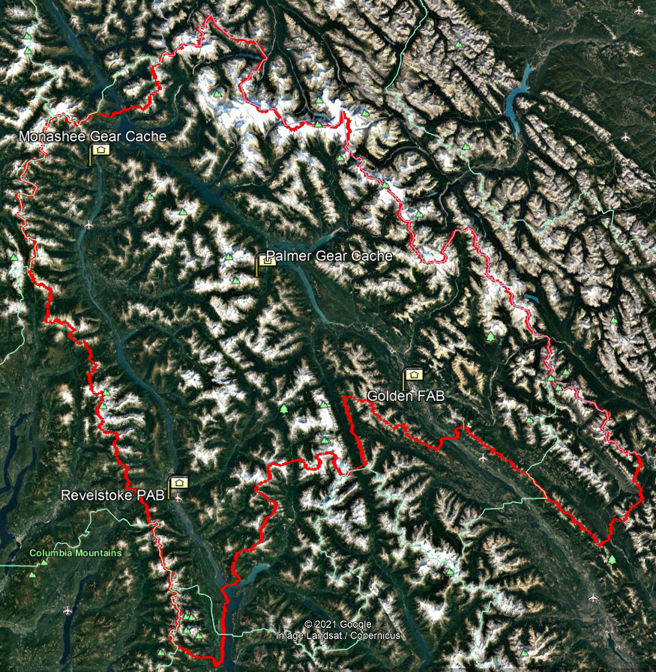

Inventory Stocking List in Caches *May vary slightly due to fires
ITEM | QUANTITY
PUMP - MARK 3 OR WICK 375 | 1
HOSE - SUCTION, 2" WITH FOOT VALVE KIT | 1
PUMP - TOOL BOX, KIT (WITH TOOLS AND FITTINGS) | 1
TANK - HELICOPTERABLE, 60 IMP GAL | 2
FUNNEL - GRAVITY, C/W 3 ANCHOR ROPES | 1
VALVE -3 WAY FOR 1-1/2" HOSE | 2
VALVE - WATER THIEF, WITH SHUT OFF | 4
NOZZLE - MULTI-APERTURE, 1-1/2" Q.C. ( HANSEN STYLE) | 2
NOZZLE - FIRE HOSE, 5/8" ECONOFLO | 6
VALVE - 3 WAY FOR 5/8" HOSE | 3
NOZZLE - FOG, PLASTIC | 1
STRANGLER - HOSE | 1
PUMP - BACKPACK, COLLAPSIBLE, 5 GAL. | 1
SHOVEL - FIRE | 2
HOSE - DISCHARGE, 1 1/2" X 100', PERC AND NON PERC | 5
HOSE - DISCHARGE, 1" X 100', PERC AND NON-PERC | 10
HOSE - DISCHARGE, 5/8" X 50' | 15
POUCH - WEDGE/FILE (FOR CHAINSAW OPERATOR) | 1
CHAINSAW - WRENCH, SPARK PLUG, FLAT END FOR HUSKY | 1
FILE -AXE, 8" | 1
FILE - CHAINSAW, 7/32" | 1
WEDGE - FALLERS, 8" X 1-1/4" | 2
WEDGE - FALLERS, 10" X 1" | 2
CAN - FUEL, 5 GAL. | 1
FUEL LINE - SINGLE (FOR 5 GAL. GAS CAN) | 1
CAN - FUEL/OIL, COMBO | 1
FLAGGING - LIME, GLOW | 20 ROLLS
FLAGGING - ORANGE, GLOW | 20 ROLLS
FLAGGING - PINK, GLOW | 20 ROLLS
BATTERIES - AA & AAA | 1 BOX/EA
OIL - MOTOR (FOR 2 STROKE 500ML) | 12
OIL - CHANSAW BAR, 4 LITRE | 1
FIRST AID - KIT, LEVEL 3, BACKPACK | 1
FIRST AID - OXYGEN, KIT WITH 400L D CYLINDER | 1
BLANKETS | 6
FIRST AID - STRETCHER, BASKET | 1
FIRST AID - BAG (FOR BASKET STRETCHER) | 1
FIRST AID - BOARD, SPINE | 1
FIRST AID - SPLINT, WOOD, PADDED, SET OF 3 | 1
TARPAULIN - 6' X 8' GROUND SHEET | 1
WATER - BOTTLED, 500ML, 24 PER CASE | 4
CMH Monashees Lodge – Rescue Cache
52° 10.257, -118° 34.524
Located roughly 145km up Highway 23N, just past Mica townsite.
The rescue stretcher and first aid gear can be found inside the heli shack, which is unlocked.

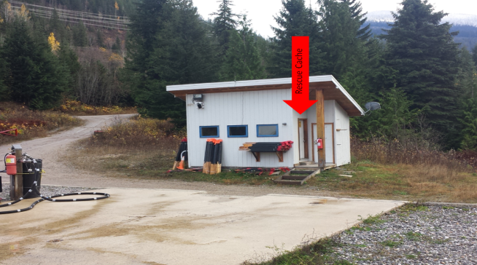

The rescue bag stretcher and first aid gear are inside the shack.

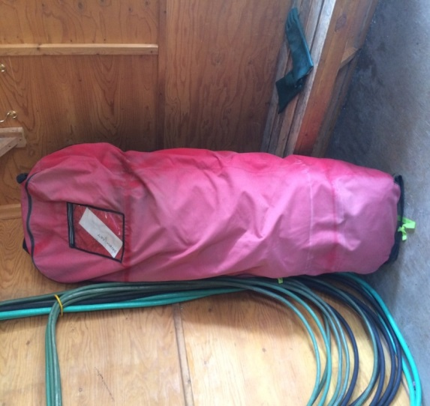

The fire rescue gear is found in dry boxes behind the heli shack, requiring a #3252 key.
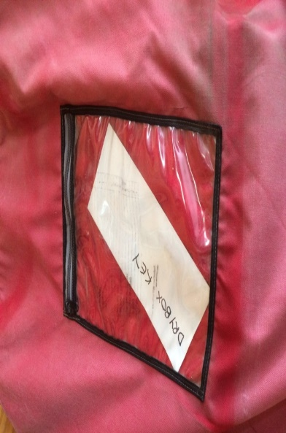
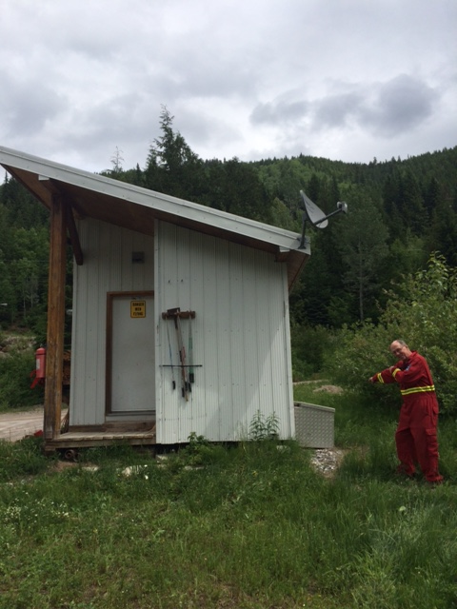

For crews from out of Zone there is a key for the dry boxes stored in an envelope in the front pouch of the rescue stretcher cover

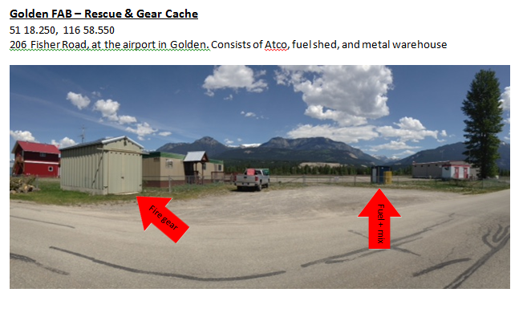

Orientation Tools
Please ensure you have a Kootenay Back Roads Map Book.
SEFC geo-referenced maps for use in Avenza are located here: G:\!Publish\Zones\Columbia\Plans\Mapping\Southeast Fire Centre Avenza Maps
(Note: you will have to map the SEFC G drive on your computer to be able to access these)

GPS Garmin Legend Setup
Time 24 hour, Pacific Time zone
Display 15 seconds Interface: Garmin
Units hddd mm.mmm’ NAD83: Metric, Meters, m/min
Headings Degrees, True System: Normal, WAAS Enabled

Crews
The Columbia Fire Zone has 2 Unit Crews and 4 (for 2021) IA crews.

Rotation
Visiting crews will be given the same opportunity to action fires as our locals. As crews arrive from out of zone they will be slotted into the bottom of our rotation. As fires come up and crews are dispatched, each crew in turn will move up in the rotation. As a crew completes their fire and returns to base they will slot in at the bottom.
**The ZWCO has the authority to alter the rotation for operational purposes (i.e. using local crew to dispatch at night, managing fatigue/OSWS2).

Smoke Chases
A crew going on a smoke chase loses their first out status only if they get 3+ hours overtime.

Call Outs
A crew getting an overtime call-out loses their first out status.

Stand By
Stand-by will be set by the RWCO.

Ferries
If you are traveling out of our zone to the south, you will need to utilize the Galena-Shelter Bay Ferry. It is a free ferry that travels South on the hour and North on the ½ hour. During peak summer tourism hours there may be a second ferry that carries the overload at un-scheduled intervals. If you are responding to a fire the ferry crew may be able to priority board you, provided they have advanced notice. Check in with dispatch to make the necessary arrangements.

Gasoline in approved containers is permitted on BC Ferries in limited amounts, not exceeding 25 liters. Foot passengers are not allowed to carry gasoline on board the ferry. Vehicles may only carry 1 spare container of gasoline. There is a fuel cache located at the Nakusp Fire Attack Base. Inform the ZWCO if you intend to use this cache.

SEFC Weather Briefings
Mondays & Thursdays 09:15
Weather conference 1-778-401-6289
Phone Conference ID: 582 531 812#
Microsoft TEAMS Link: Click here to join the meeting
****Please be sure to mute your phone****

*Daily Briefings @ 09:15 with heightened activity & or weather
*You must dial 8 to get out in Golden

Columbia Fires
- Due to extremely rough terrain and remote locations, most fires in zone are helicopter access only. It is common practice to dispatch IA crew members by helicopter and IA truck to follow for support.
- It is not uncommon to be on slopes greater than 100%.
- Low to mid elevation fires are typically in cedar-hemlock forests. It is easy to underestimate the workload required to effectively suppress these fires.
  - Request a second IA crew, UC squad, contract crew, or chainsaw falling Qualified Assistance if necessary.
  - On larger / dug-in targets consider alternate water sources to stilwells (relay tank, Mark III/hose lay, etc.)
- IA fires in the Columbia Zone cedar-hemlock forest often require more water than a standard target. It is recommended to prepare your crew with 3 extra stilwells beyond the standard 2.
- There is a vast network of industry roads, but conditions are variable and directions difficult without good quality maps (Kootenay Back Roads) and/or local knowledge.
- If it is possible to drive and there is no water supply nearby, there are off road water tenders available. Please check with the ZWCO.
- Falling trees in this zone can be extremely difficult and dangerous. If you have any doubt about your safety when assessing or falling large or hazardous trees (burnt out cedars with multiple tops) do not hesitate to ask for qualified assistance. SEFC or MZOC Operations will provide support as required.
- If a hoist extraction is the only option for a first aid incident notify dispatch prior to engaging
- Good quality documentation in the form of notes, photos and maps are expected. The electronic final fire report must be completed in a timely fashion.

Medical Services
Emergency - 911
Queen Victoria Hospital (with helipad) - 1200 Newlands Rd Revelstoke, 250-837-2131
Selkirk Medical Clinic - 101 1st St, Revelstoke, 250-837-9321
Mountain View Medical Clinic – 616 Third St. West Revelstoke, 778-486-8018
Golden General Hospital - 835 9th Ave S, Golden, 250-344-5271
Golden Medical Clinic - 826 S 9th Avenue Golden, 250-344-2211

Information
In the Ops Building there are clipboards with the most current weather and indices posted, in addition to the large whiteboard with current fire behavior predictions for a variety of local weather stations.

There is also a safety\aviation board in the zone kitchen with current information regarding Occupational Health and Safety messages and the latest Air Bulletins.

Conclusion
If you are here, it means that we are experiencing or expecting significant fire starts and/or fire behavior. We will do our best to keep you and all crews informed. Please report to work at 08:30 sharp unless otherwise noted. If there are no immediate fire requirements your crew will be asked to participate in local project work. Our crews take physical fitness training at the beginning of the day. You are welcome to participate if so inclined.

Columbia Fire Zone

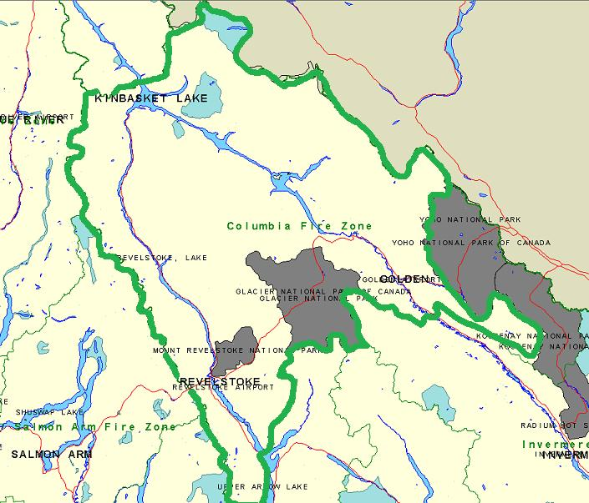

Radio Operations Map
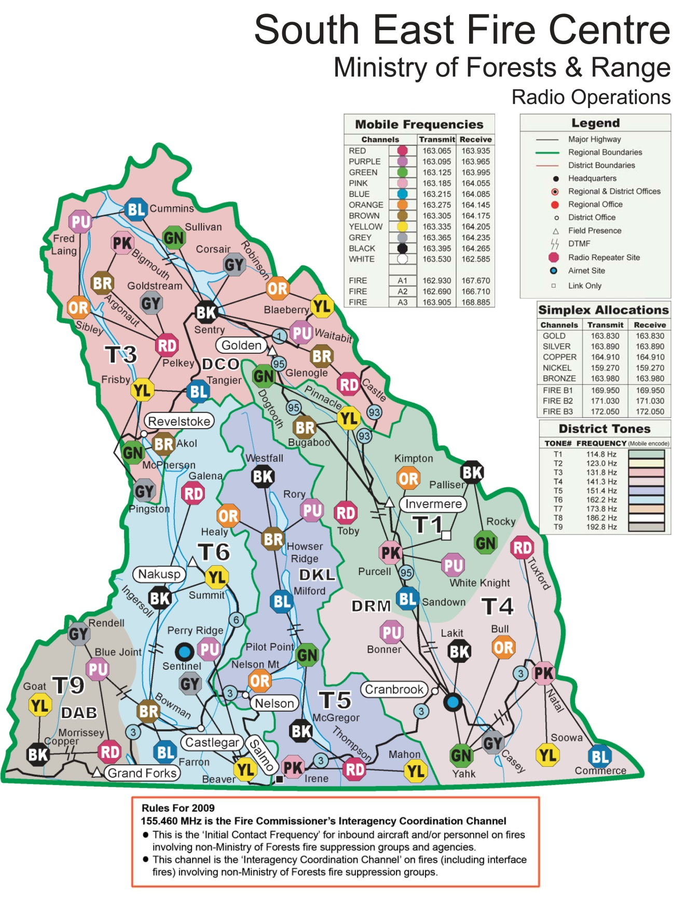

Restaurants
Yellow highlighted choices are local recommendations! *not an inclusive list

Revelstoke

A&W, McDonalds, Subway, Tim Hortons - $
All on highway strip.

Chubby Funsters- $$$
Upscale Pub (Lunch & Dinner)
114 MacKenzie Ave, 250 837-5552

Conversations Coffee House - $ Sandwiches, soups, baked goods (Breakfast & Lunch)
205 MacKenzie Ave, 250 837-4772

Denny's Restaurant - $
Open 24 hours - at the Sandman Inn
1891 Fraser, 250 837-4772

Emo's - $$
Pizza, pasta, steak, souvlaki (Lunch & Dinner)
418 1st St W, 250 837-6443

Frisby Ridge Teriyaki - $$
Japanese, Korean (Lunch & Dinner)
201 1st St W, 250 837-5449

The Taco Club -$
Classic Mexican
206 Mackenzie Ave
250 837 0988

Grizzly Sports Bar - $
Pub Food (Lunch & Dinner)
314 1st St W, 250 837-5576

Kawakubo - $$$
Upscale Japanese (Lunch & Dinner)
109 1st St E, 250 837-2467

Kevin’s Kitchen
Healthy Chinese
302 1st W.
250 837-2818

La Baguette - $
Sandwiches, wraps, baked goods, gelato (Breakfast & Lunch)
607 Victoria Rd, 250 837-3755

Main Street Cafe - $$
Breakfasts and coffee (Breakfast & Lunch)
317 MacKenzie Ave, 250 837-6888

The Modern Bakeshop - $
Breakfasts, sandwiches, baked goods, coffee (Breakfast & Lunch)
212 Mac Kenzie Ave,
250 837-6886

The Nomad - $
Fast food from scratch (Lunch & Dinner)
1601 Victoria Rd, 250 837-4211

The Village Idiot - $$
Good quality pub food (Lunch & Dinner)
306 MacKenzie Ave, 250 837-6240

Woolsey Creek - $$$
Upscale Ethnic (Dinner)
600 2nd St W, 250 837-5500

Zalas - $$$
Steak, pizza, pasta (Dinner)
1601 Victoria Rd, 250 837-5555

Golden

A&W, McDonalds, Subway, Dairy Queen, Tim Hortons - $
All on highway strip.

APOSTOLES -$$
Specializing in Greek cuisine, (serving Packers Place).
428 9th Ave, N. Golden BC (250) 344-4906

BIG BEND CAFE - good breakfast - $$
528 9th Avenue North, Golden BC. (250) 439-1995

CANYON'S EDGE - $$
Live on the edge, check out Golden’s newest dining experience!
1416 Golden View Rd Golden, BC (250) 344-3693

CEDAR HOUSE RESTAURANT - $$$
Fine dining in magical mountain setting.
735 Hefti Rd, Golden BC. (250) 344-4679

ELEVEN22 - $$
Fun dining, platters with personality!
1122 10th Ave. S Golden BC. (250) 344-2443

THE FIRE PIT - $$
Great food, great sports
1105 Trans Canada Hwy. Golden BC. (250) 344-5222

THE GOLDEN TAPS PUB - $$
Warm atmosphere.
505 9th Ave. downtown Golden BC. (250) 344-7155

HUMPTY'S - $
All styles of eggs. Open 24hrs a day!
1402 Trans Canada Hwy. Golden BC. (250) 344-5155

JITA'S CAFE - $
Healthy lunch, specialty coffees.
1007 B 11th Ave. S. Golden BC. (250) 344-3660

KICKING HORSE GRILL - $$$
Award winning restaurant. Taste the world.
1105-9th St.S. Golden BC. (250) 344-2330

MAD TRAPPER PUB - $$
Food, sports, great specials,
1203 9th St. Golden BC. (250) 344-6661

MOBERLY PUB - $$
Ten mins North of Golden. Thursday night wings.
1398 Hartley Rd., Golden BC. (250) 344-6566

OMEGA LOUNGE - $$
Every day burger special, pizza,
11th St. S. Golden BC. (250) 344-7806

PEKING INN - $
Sunday Smorg, Chinese food.
10th St. S. Golden BC. (250) 344-7806

RED TOMATO PIES - PIZZA - $
519A 9th St Golden, BC. (250) 344-4444

RIVER HOUSE - $$
Unique, fresh and organic lunch options.
Downtown next to pedestrian bridge. Golden BC. (250) 344-4660

SMITTY'S - $$
(serving to Jiggers Lounge)
1205 Trans Canada Hwy. Golden BC. (250) 344-6513

TIMBER MILL RESTAURANT - $$
Variety of Canadian cuisine. - Close to Parson
1202 Trans Canada Hwy. Golden BC. (250) 344-7222

WHITETOOTH BISTRO - $$
427 9th Ave N Golden, BC (250) 344-5120

Approved Accommodation
**Please consult the online approved accommodation list for rates and updates as this list can change from shoulder to peak tourism seasons.**

Revelstoke

Sandman Hotel Revelstoke
1901 Laforme Blvd.
Revelstoke, V0E 2S0

The Hillcrest Hotel, A Coast Resort
2100 Oak Drive
Revelstoke, V0E 2S0

Courthouse Inn
312 Kootenay St
Revelstoke, V0E 2S0

Days Inn & Suites
301 Wright St.
Revelstoke, V0E 2S0

Sutton Place Hotel - Revelstoke Mountain Resort
2950 Camozzi Road
Revelstoke

Golden

Ponderosa Motor Inn
1206 Trans-Canada Hwy
250-344-2205

Glenogle Mountain Lodge & Spa
913 Oster Rd
Golden, V0A1H0

Ramada Inn
1311 - 12 St North
Golden, V0A1H0

Prestige Inn Golden
1049 Trans-Canada Hwy
250-344-799

